The table below provides a summary of the following variables. Chi-Square test was used for categorical variables while ANOVA test was used for continuous variables to test whether treatment had an impact on any of the variables. Chi-square test compares proportion of those in treatment versus those in non-treatment group. ANOVA test compares group means between treatment and non-treatment group. The summary statistics for those who got treatment versus those who did are comparable; mean for continuous variables and frequencies for categorical variables. This suggests that randomized was properly done.

**Categorical variables:** actions status, appeared, transient, sex, race

|  |  |  |  |  |  |
| --- | --- | --- | --- | --- | --- |
|  | Overall | Treatment | No Treatment | p-value | Test |
| n | 8285 | 4132 | 4153 |  |  |
| **AGE** (mean (sd)) | 39.31 (13.69) | 39.42 (13.74) | 39.21 (13.65) | 0.489 | Anova |
| **RACE** (%) |  |  |  | 0.711 | Chi-sq |
| Asian | 90 ( 1.1) | 43 ( 1.0) | 47 ( 1.1) |  |  |
| Black | 1982 (23.9) | 1000 (24.2) | 982 (23.6) |  |  |
| Hispanic | 320 ( 3.9) | 149 ( 3.6) | 171 ( 4.1) |  |  |
| Native American | 302 ( 3.6) | 146 ( 3.5) | 156 ( 3.8) |  |  |
| White | 5591 (67.5) | 2794 (67.6) | 2797 (67.3) |  |  |
| **SEX** (%) |  |  |  | 0.797 | Chi-sq |
|  | 2 ( 0.0) | 1 ( 0.0) | 1 ( 0.0) |  |  |
| F | 1933 (23.3) | 977 (23.6) | 956 (23.0) |  |  |
| M | 6350 (76.6) | 3154 (76.3) | 3196 (77.0) |  |  |
| **TRANSIENT**=TRANSIENT (%) | 2909 (35.1) | 1452 (35.1) | 1457 (35.1) | 0.975 | Chi-sq |
| **ACTION AMOUNT** (mean (sd)) | 30.43 (129.70) | 30.20 (143.26) | 30.65 (114.64) | 0.875 |  |
| **ACTION STATUS** (%) |  |  |  | 0.646 | Chi-sq |
|  | 7481 (90.3) | 3751 (90.8) | 3730 (89.8) |  |  |
| CONTINUED BY COURT | 15 ( 0.2) | 7 ( 0.2) | 8 ( 0.2) |  |  |
| CONTINUED BY DEFENDANT | 22 ( 0.3) | 10 ( 0.2) | 12 ( 0.3) |  |  |
| DEFENDANT ADVISED | 1 ( 0.0) | 0 ( 0.0) | 1 ( 0.0) |  |  |
| DEFENDANT NOT BROUGHT IN | 4 ( 0.0) | 4 ( 0.1) | 0 ( 0.0) |  |  |
| DEFERRED JUDGMENT | 20 ( 0.2) | 9 ( 0.2) | 11 ( 0.3) |  |  |
| DEFERRED PROSECUTION | 18 ( 0.2) | 9 ( 0.2) | 9 ( 0.2) |  |  |
| DISM ON MOTION OF PROSECUTION | 35 ( 0.4) | 17 ( 0.4) | 18 ( 0.4) |  |  |
| DISMISS W/PREJUDICE BY COURT | 1 ( 0.0) | 0 ( 0.0) | 1 ( 0.0) |  |  |
| DISMISSED | 49 ( 0.6) | 24 ( 0.6) | 25 ( 0.6) |  |  |
| FAILED TO APPEAR (FTA) | 17 ( 0.2) | 6 ( 0.1) | 11 ( 0.3) |  |  |
| GUILTY PLEA IMMEDIATE SENTENCE | 556 ( 6.7) | 262 ( 6.3) | 294 ( 7.1) |  |  |
| GUILTY PLEA SET NEW DATE | 6 ( 0.1) | 2 ( 0.0) | 4 ( 0.1) |  |  |
| NOT GUILTY PLEA SET NEW DATE | 59 ( 0.7) | 30 ( 0.7) | 29 ( 0.7) |  |  |
| SET NEW COURT DATE | 1 ( 0.0) | 1 ( 0.0) | 0 ( 0.0) |  |  |
| **APPEARED** = 1 (%) | 5208 (62.9) | 2555 (61.8) | 2653 (63.9) | 0.057 | Chi-sq |

**Continuous variables:** age, action amount

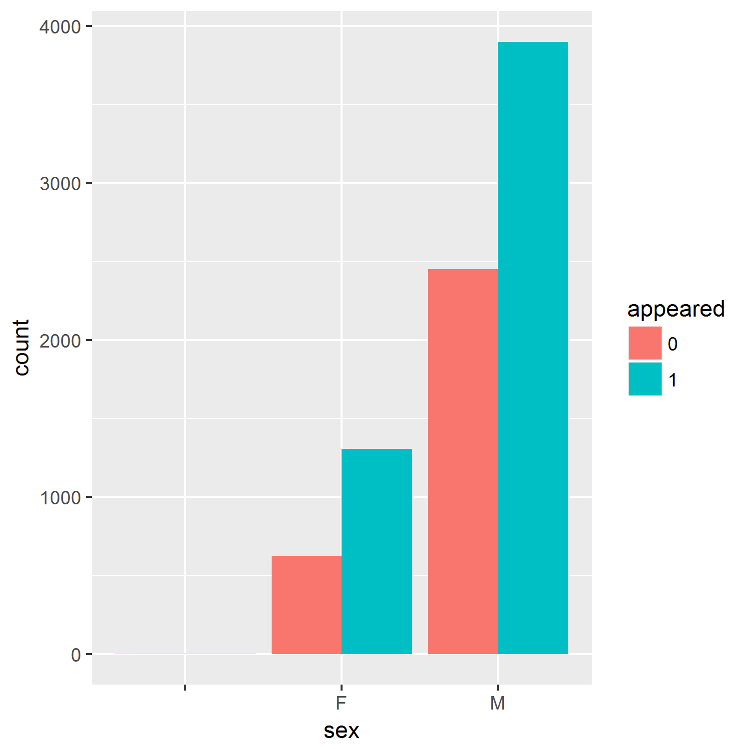

There is a higher proportion of males in the study than females. In both sexes, more people appeared for the first arraignment that did not.

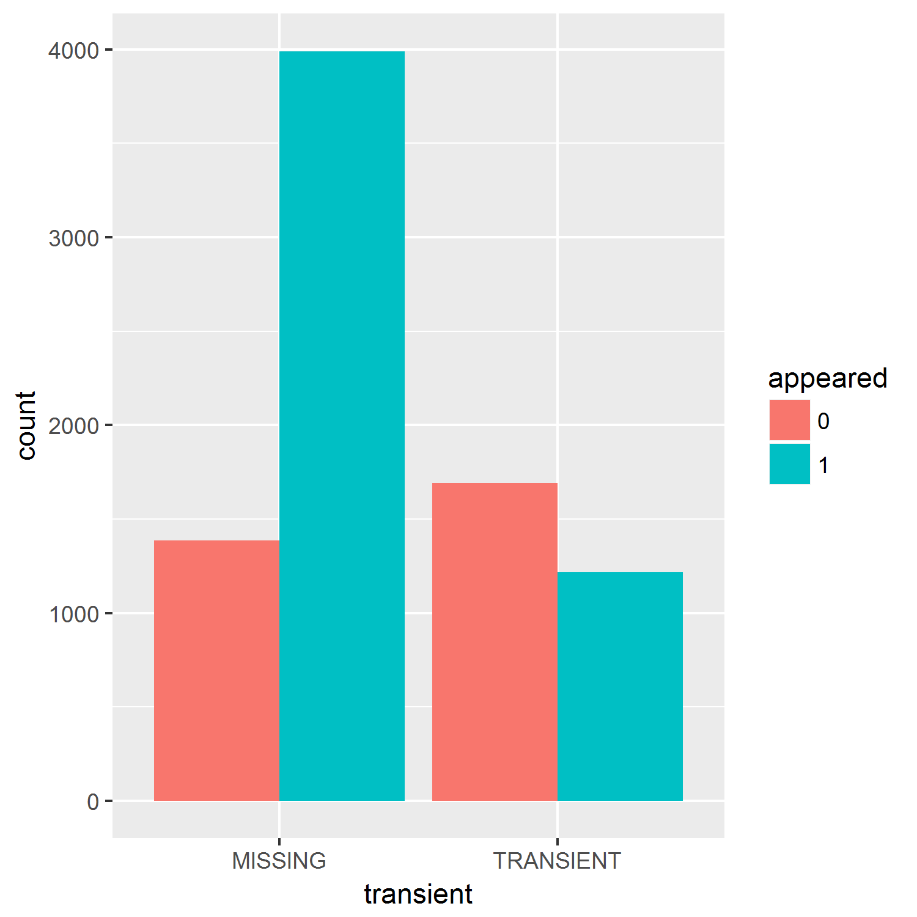

Among those were transient, a lower proportion of people appeared.

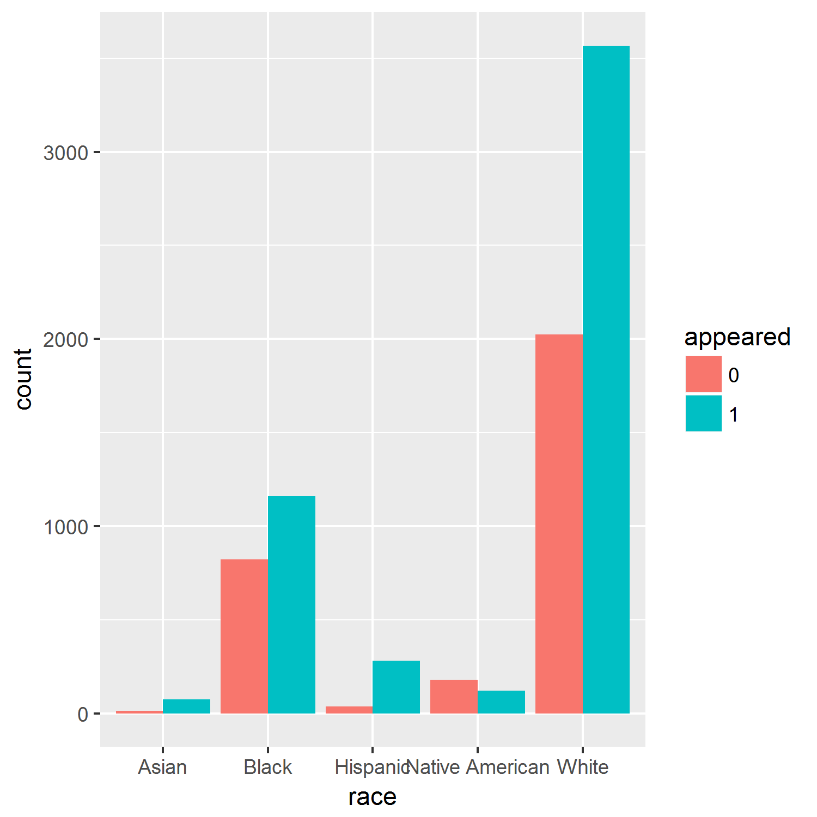

More people appeared in all races except Native Americans. It would be interesting to collect more variables such as transportation means to see if transportation influences appearance.

**Logistic Regression Results**

|  |  |  |
| --- | --- | --- |
| VARIABLE | ODDS RATIO | P-Value |
| Treatment | 1.103434 | 0.043 |
| Age | 0.984343 | < 2e-16 |
| Race: Black | 0.31657 | <0.001 |
| Race: Hispanic | 1.054757 | 0.879 |
| Race: Native American | 0.218945 | 2.92e-06 |
| Race: White | 0.385736 | 0.002 |
| TRANSIENT | 0.287802 | < 2e-16 |
| Action Amount | 0.997176 | < 2e-16 |

A quick look at the data showed that some of the defendants reported more than once. However, the case numbers were all unique thus no duplicate of subject ids were removed to reflect that the cases were different even if the subjects were the same. Based on the summary statistics from Table 1, only the appearance was influenced by treatment. However, the p-value was 0.057 suggesting that this was only marginally significant. A logistic regression analysis was performed to analyze whether any of the variables collected had an impact on the whether or not the defendant would appear for the first arraignment.

Holding everything else constant, the odds of appearing when you are black is .31657, when Hispanic, 1.05, when Native American, .22, when White, .39. However, being Hispanic was not statistically significant with p-value of .879. Holding everything else constant you will see a 10% increase in odds of appearing that without treatment. This suggests that the treatment works for this study population.

One question I would have for the team implementing this trial is whether or not the new court summons were translated into Spanish. For the next trial, the policy makers can include mean of transportation as one of the variables to see if it is a factor in appearance. Intuitively this would be a factor, however, if an intervention is to be done, this could be an important variable to analyze.